TENANTFLOW.AI — AI OPERATIONS LAYER
Next.js Dashboard & FastAPI Architecture
Comprehensive Implementation Plan
📌 Executive Technical Summary
This document provides the complete, production-ready technical implementation plan for building the TenantFlow.ai AI Operations Dashboard. It details the exact Next.js App Router component structure, PostgreSQL database schema additions, FastAPI REST endpoints, and WhatsApp real-time integration workflows.

1. Project Analysis & Current Standing
1.1 Current Architecture Overview
The project currently operates as an enterprise-grade AI automation engine for real estate property management:
- • Backend Framework: Powered by Python FastAPI (langgraph_agent/app/server.py) hosting REST routers across Maintenance, FAQ, Tenants, and Properties.
- • Agent Pipeline: Uses LangGraph multi-agent pipeline (langgraph_agent/app/pipeline.py) orchestrating specialized subgraphs (Maintenance, FAQ/Search, Rent Reminder, Lease Renewal).
- • Database & Persistence: Backed by Neon PostgreSQL with AsyncPostgresSaver checkpointer for state persistence across human-in-the-loop approvals.
- • Live Channels: Production Meta Cloud API webhook handler (langgraph_agent/input_channels/whatsapp_server.py) for WhatsApp tenant messaging.
1.2 Gaps Identified for Dashboard Integration
To build the Next.js production dashboard according to your 5 target screenshots, the following core backend capabilities must be added:
- 1. Missing Conversations & Messages SQL Tables: Currently, channel inputs pass raw text into LangGraph. LangGraph saves graph checkpoints, but there is no structured SQL conversations table or messages table for rapid querying, filtering, and rendering transcripts in the UI.
- 2. Missing Dashboard REST Aggregator Endpoints: Existing endpoints expose raw DB tables or basic Prometheus metrics. The dashboard requires aggregated summary metrics (Automation Rate %, Avg Response Time, Needs Attention actionable queue, Agent Activity breakdown).
- 3. Next.js Frontend Application Setup: A dedicated Next.js (App Router) project must be established with clean type definitions, API clients, and component abstractions.
2. Target Screenshots & Page Breakdown Analysis
Every card, filter, table, and action from your 5 screenshots is mapped to precise backend API endpoints and PostgreSQL tables:
Page / Screenshot | Primary UI Elements & Cards | Required API Endpoints & Data Source
1. Overview  (input_file_0.png) | • Top Stat Cards: Conversations (428), AI Resolved (391), Human Escalations (37), Automation Rate (91.4%), Avg. Response Time (18s)  • Needs Attention: Urgency cards (Water Leak, Rent Overdue, Owner Report) with Review/Approve actions  • Agent Activity Today: Workflow runs & success rates  • Automation Status: Active automation health | GET /api/v1/dashboard/overview  POST /api/v1/human-escalations/{id}/action  (DB: tenants, maintenance_tickets, human_escalations)
2. Conversations List  (input_file_1.png) | • Multi-Filter Bar: Search, Property, Unit, Channel, Intent, Urgency, Status, Date Range  • Conversations Data Table: Date & Time, Property/Unit, Contact, Channel, Intent, Urgency, Workflow, Status, Action link  • Pagination & Count: 'Showing 1 to 3 of 142 entries' | GET /api/v1/dashboard/conversations  (Query Params: search, property_id, channel, status, page, limit)  (DB: conversations, tenants, properties)
3. Conversation Detail  (input_file_2.png) | • Transcript Panel: Full chat history (User text, AI response, SYSTEM: INTENT CLASSIFIED event tags)  • Decision Context: Classified Intent, Calculated Urgency, Escalation Status  • Conversation Info: Property, Unit, Contact, Channel, Triggered Workflow  • Actions: Mark Reviewed, View Workflow | GET /api/v1/dashboard/conversations/{id}  POST /api/v1/dashboard/conversations/{id}/review  (DB: conversations, conversation_messages)
4. Automations Grid  (input_file_3.png) | • Workflow Cards: Maintenance Request, Rent Reminder, Resident Support, Lease Renewal, Owner Reporting  • Card Details: Active badge, Handles description, Channels, Escalation Conditions list, Scope ('All Properties (42)'), View Details, Configure buttons | GET /api/v1/dashboard/automations  PATCH /api/v1/dashboard/automations/{id}  (DB: workflows_config, properties)
5. Agent Activity  (input_file_4.png) | • Execution Metrics: Total Executions (428), AI Completed (391), Escalations (37), Failed (4), Automation Rate (91.4% ^2.1%) with Time Filter (Today, Yesterday, Last 7 Days)  • Workflow Performance Table: Runs, AI Resolved, Escalated, Failed, Auto Rate %, Export CSV  • Recent Executions Timeline: Live execution log feed | GET /api/v1/dashboard/agent-activity  GET /api/v1/dashboard/agent-activity/export  (DB: audit_logs, dead_letter_jobs)

3. Architecture & Production Best Practices
To ensure production reliability and prevent tight coupling:
- 1. Strict Decoupling: The Next.js frontend interacts exclusively with FastAPI REST endpoints. Next.js server components or client hooks never execute SQL directly.
- 2. Real-Time Live Data Binding: When a tenant sends a WhatsApp message, the webhook logs the event to PostgreSQL in real time, allowing the Next.js UI to display real live updates immediately.
- 3. Standardized API Envelopes: FastAPI uses Pydantic schemas to guarantee type safety between Python backend models and Next.js TypeScript interfaces.

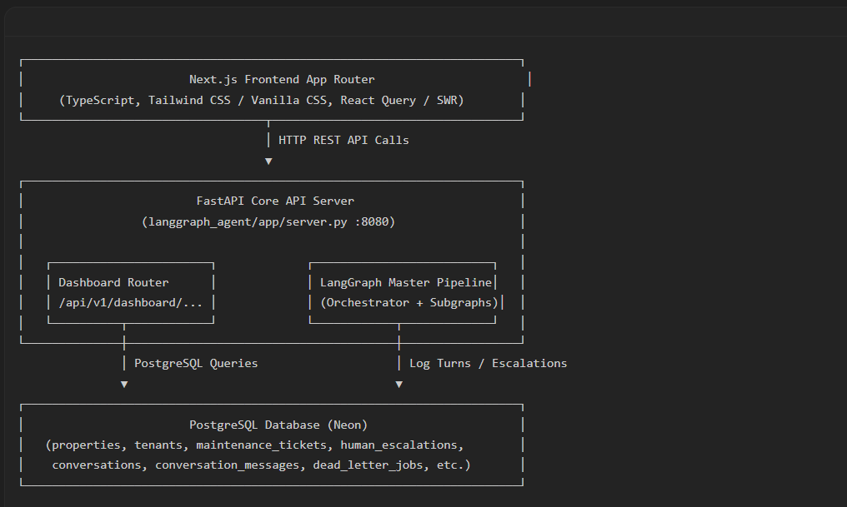

4. Next.js Directory & Component Architecture
The frontend is structured cleanly inside the `frontend/` directory using Next.js 14 App Router:
frontend/
├── package.json
├── next.config.mjs
├── tsconfig.json
├── app/
│ ├── layout.tsx # Global Root Layout (Sidebar + Top Navbar)
│ ├── page.tsx # Redirect to /overview
│ ├── globals.css # Design Tokens, Color Variables & Aesthetics
│ ├── overview/
│ │ └── page.tsx # Overview Dashboard Page (Screenshot 0)
│ ├── conversations/
│ │ ├── page.tsx # Conversations List Page (Screenshot 1)
│ │ └── [id]/
│ │ └── page.tsx # Conversation Transcript & Details (Screenshot 2)
│ ├── automations/
│ │ └── page.tsx # Automations Configuration Grid (Screenshot 3)
│ └── agent-activity/
│ └── page.tsx # Agent Activity & Log Timeline (Screenshot 4)
├── components/
│ ├── layout/
│ │ ├── sidebar.tsx # Left Navigation Sidebar (TenantFlow.ai branding)
│ │ └── top-bar.tsx # Top Search Bar, Notifications, User Profile
│ ├── overview/
│ │ ├── summary-cards.tsx # Stat Cards (Conversations, Automation Rate, etc.)
│ │ ├── needs-attention-card.tsx # Critical Action Items with Approve/Review buttons
│ │ └── activity-today-table.tsx # Workflow Runs & Success Rates
│ ├── conversations/
│ │ ├── conversation-filters.tsx # Property, Unit, Urgency, Intent filters
│ │ ├── conversation-table.tsx # Filtered Data Table & Pagination
│ │ ├── transcript-feed.tsx # Chat Bubbles & SYSTEM event badges
│ │ ├── decision-context-card.tsx # Intent, Urgency, Escalation summary
│ │ └── conversation-info-card.tsx # Property, Tenant, Channel details
│ ├── automations/
│ │ └── automation-card.tsx # Workflow Rule Card with active toggle & conditions
│ ├── agent-activity/
│ │ ├── performance-table.tsx # Workflow Performance matrix with CSV export
│ │ └── execution-timeline.tsx # Real-time execution log feed
│ └── ui/ # Reusable UI primitives (Badge, Card, Button, Modal)
└── lib/
├── api-client.ts # Axios/Fetch wrapper for FastAPI calls
├── types.ts # TypeScript interfaces matching backend models
└── utils.ts # Date formatters, status color helpers

5. Phased Chunk-by-Chunk Implementation Roadmap
The project implementation is divided into 6 modular, testable chunks:
Chunk 1: Database Schema Expansion & Backend Dashboard API Engine
Goal: Create structured conversation storage in PostgreSQL and build core aggregator REST endpoints in FastAPI.
• Database Migration (database/migrations/007_add_conversations_and_messages.sql):
CREATE TABLE IF NOT EXISTS conversations (
conversation_id VARCHAR(50) PRIMARY KEY,
tenant_id VARCHAR(50) REFERENCES tenants(tenant_id),
property_id VARCHAR(50) REFERENCES properties(property_id),
unit_id VARCHAR(50) REFERENCES units(unit_id),
channel VARCHAR(30) NOT NULL, -- whatsapp | vapi | email | web
intent VARCHAR(100),
urgency VARCHAR(20) DEFAULT 'Normal',
status VARCHAR(30) DEFAULT 'AI Resolved',
workflow_triggered VARCHAR(100),
human_intervention VARCHAR(50) DEFAULT 'None',
is_reviewed BOOLEAN DEFAULT FALSE,
last_message_at TIMESTAMP DEFAULT CURRENT_TIMESTAMP,
created_at TIMESTAMP DEFAULT CURRENT_TIMESTAMP
);
CREATE TABLE IF NOT EXISTS conversation_messages (
message_id SERIAL PRIMARY KEY,
conversation_id VARCHAR(50) REFERENCES conversations(conversation_id),
sender_type VARCHAR(20) NOT NULL, -- tenant | ai | system
sender_name TEXT,
content TEXT NOT NULL,
system_event TEXT,
timestamp TIMESTAMP DEFAULT CURRENT_TIMESTAMP
);

• Backend Pipeline Hook & REST Routers:
- Hook handle_request() in langgraph_agent/app/pipeline.py and input_channels/whatsapp_server.py to insert incoming tenant messages and outgoing AI replies automatically into conversations & conversation_messages.
- Create langgraph_agent/app/api/routers/dashboard.py supporting GET /api/v1/dashboard/overview, GET /api/v1/dashboard/conversations, GET /api/v1/dashboard/conversations/{id}, and POST /api/v1/human-escalations/{id}/action.
• Chunk 1 Verification Plan:
- Run python database/migrations/run_migration.py to create table structure.
- Execute seed test conversation script.
- Run cURL / Pytest to verify /api/v1/dashboard/overview and /api/v1/dashboard/conversations return JSON payloads.
Chunk 2: Next.js Setup & Overview Dashboard (input_file_0.png)
Goal: Build Next.js shell and Overview Dashboard matching Screenshot 0.
- • Setup: Setup Next.js app in frontend/ with Tailwind CSS, Lucide icons, and API client in lib/api-client.ts.
- • Components: Create Overview page with 5 Top Summary Cards (Conversations, AI Resolved, Human Escalations, Automation Rate, Avg Response Time).
- • Interactive Cards: Build Needs Attention actionable cards with working Approve & Review buttons hooked to backend API.
- • Tables: Build Agent Activity Today workflow completion matrix.
• Chunk 2 Verification Plan: Launch FastAPI on :8080 and Next.js on :3000. Verify dashboard cards display real DB counts.
Chunk 3: Conversations List & Detail Transcript View (input_file_1.png & input_file_2.png)
Goal: Implement multi-filter conversations list table and real-time transcript detail view.
- • List Page: Multi-filter bar (Search, Property, Unit, Channel, Urgency, Intent, Status) with live pagination.
- • Detail View: Dual-pane transcript view: Left pane chat bubbles (User, AI, SYSTEM event badges), Right pane Decision Context & Conversation Info cards.
• Chunk 3 Verification Plan (WhatsApp Integration Test): Send an inbound WhatsApp message. Confirm it creates a record in PostgreSQL and displays live in the Next.js transcript view!
Chunk 4: Automations Grid & Human Escalation Management (input_file_3.png)
Goal: Build Automations Workflow grid and escalation action handler.
- • UI Grid: Automations Grid page (Maintenance Request, Rent Reminder, Resident Support, Lease Renewal, Owner Reporting, + New Automation).
- • Features: Active toggle, Escalation Conditions list, Scope count, Configure modals.
• Chunk 4 Verification Plan: Toggle automation state and verify database configuration updates.
Chunk 5: Agent Activity Page & Log Analytics (input_file_4.png)
Goal: Build Agent Activity metrics, Workflow Performance matrix, and recent execution timeline feed.
- • Filters: Time Filter selector (Today, Yesterday, Last 7 Days) updating execution counters.
- • Analytics: Workflow performance table with Export CSV capability.
- • Timeline: Live Recent Executions timeline feed showing execution status pills.
• Chunk 5 Verification Plan: Verify period filters recalculate execution stats from audit logs.
Chunk 6: End-to-End System Testing & Production Hardening
Goal: Complete integration check and CORS verification.
- • Security: Verify CORS settings allow http://localhost:3000.
- • E2E Flow: End-to-End Test: Inbound WhatsApp message -> LangGraph processing -> SQL insertion -> Next.js Live UI render -> Human Escalation Approval.
6. Summary of Proposed File Modifications & Additions
• Backend Modifications:
- database/migrations/007_add_conversations_and_messages.sql (NEW)
- database/conversation_repository.py (NEW)
- langgraph_agent/app/api/routers/dashboard.py (NEW)
- langgraph_agent/app/server.py (MODIFY - mount dashboard router)
- langgraph_agent/app/pipeline.py (MODIFY - insert conversation log hooks)
- langgraph_agent/input_channels/whatsapp_server.py (MODIFY - log channel metadata)
• Frontend Additions:
- frontend/ (NEW Next.js application directory with full App Router structure)
7. Verification Plan & Automated Commands
# 1. Run Database Migration
python d:/ELARION/elarion_realestate_agent/database/migrations/run_migration.py
# 2. Run Backend Integration Tests
pytest d:/ELARION/elarion_realestate_agent/langgraph_agent/tests -k dashboard
# 3. Launch FastAPI Backend Server
python -m uvicorn app.server:app --host 0.0.0.0 --port 8080 --reload
# 4. Launch Next.js Frontend Server
cd frontend && npm run dev

